**National College of Ireland**

Higher Diploma in Science in Computing

**Distributed Systems**

**Terminal Based Assignment Assessment**

**(TABA)**

Saturday 4th May, 09:00 am to Tuesday 8th May, 23:55 pm

**Lecture: Mark Cudden**

Repository:

<https://github.com/sergio-oliveira-br/distsys>

Sergio Vinicio da Silva Oliveira

[**x23170981@student.ncirl.ie**](mailto:x23170981@student.ncirl.ie)

**1. Consider that you are designing a "Product Management" system that supports at least four operations.**

* **Explain and differentiate between the four kinds of service methods supported in gRPC.**
* **Include appropriate proto file definitions and sample code in your explanations.**
* **How would each type of method be used?**
* **How would these methods be defined in the proto file?**
* **What would the corresponding code look like?**

Just a little introduction.

In gRPC, it is possible for a client application to directly call a method in a server application on a different machine as if it were a local object, which simplifies the creation of distributed applications and services.

Is based around the idea of defining a service, specifying the methods, where I will explore a lit bit more, that can be called remotely with their parameters and return types.

The image below is a representation of the concept of connection.

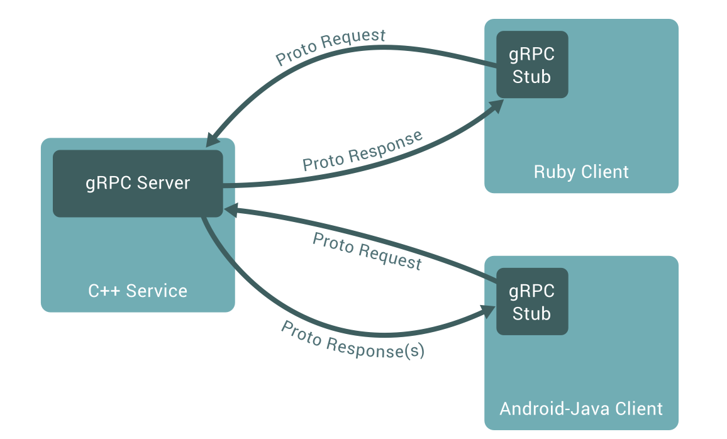

gRPC (2023) *Introduction to gRPC*. Available at: <https://grpc.io/docs/what-is-grpc/introduction/>

[Accessed 7 May 2024].

Implementing the gRPC concept.

Keep in mind that the theme will be built around a bookstore, and these are the attributes of the object of study.

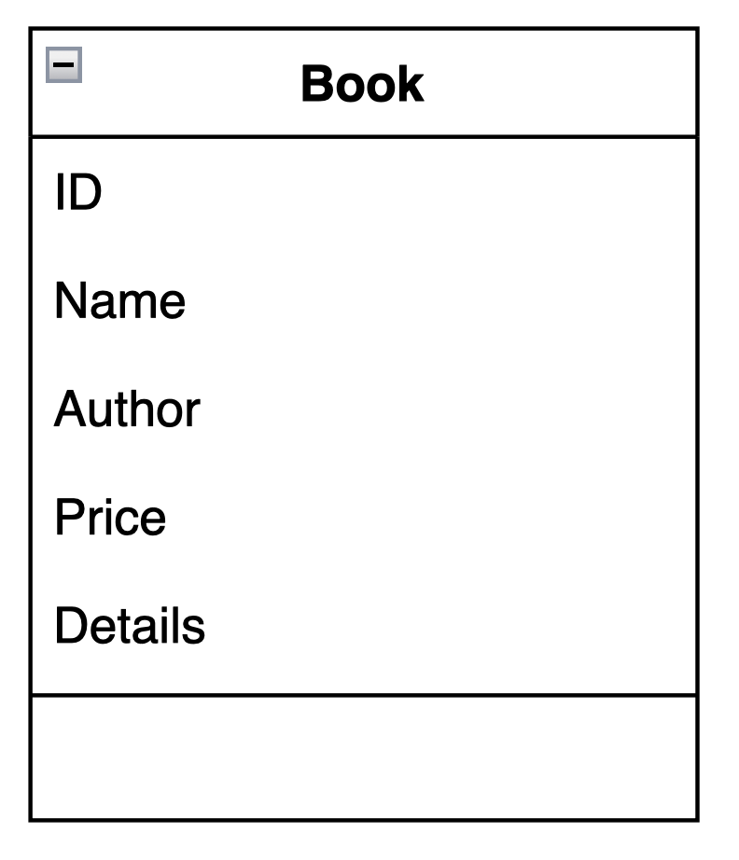

The image below represents the implementation of the SalesServices service using the Protocol Buffer version proto3, line 16.

To define a service in gRPC, we proceed as described in line 19. Then, the RPC methods can be defined in our service definition by specifying their request and response types, as we can see in line 22.

This service in particular, addresses the idea of Unary RPC, aiming to provide the user with details about a particular book.

As previously mentioned, the proto file also contains protocol buffer message type settings for all request and response types used in our service methods. Through line 26 represented the client side, and line 29 represented the server side, we establish these definitions.

The user request the information about one specific book using ID. Then, the server responds returning an information type String.

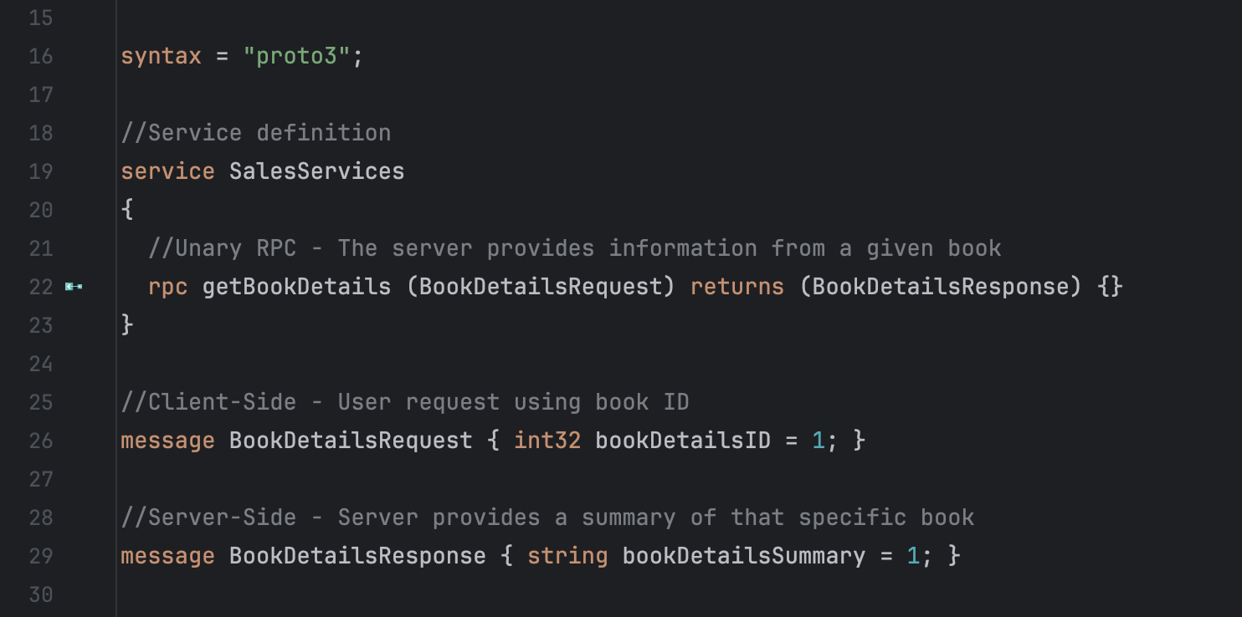

Introducing another service implementation, this one focused on Client-Side Stream and Bidirectional Stream.

Through the image below, we can observe a structure similar to that previously mentioned. But this time the service definition has two different methods.

Line 23 illustrates the implementation of the Client-Side Stream, and in line 27 Bidirectional Stream implementation.

In both instances, the methods' definitions contain the keyword “stream”, which means the existence of transmission.

The method addBookImages( ) proposes the idea that the user can send a collection of images related to a specific book to the server, and the server will respond with a single response. This concept is related to the Client-Side Stream approach.

Nonetheless, the method insertBulkDiscounts( ), allows the user to make numerous adjustments to the individual prices on many books, the server then responds individually to each request.

It's important to point out that the proposal is designed to accommodate a large number of individuals.

To illustrate the idea, consider that a 10% reduction will be implemented in all books in a certain segment.

In contrast to the Client-Side Stream, Bidirectional approach, allows the server responds with a single response. This time, we will be given individual confirmation for each adjustment made, as well as the freedom of individual adjustments.

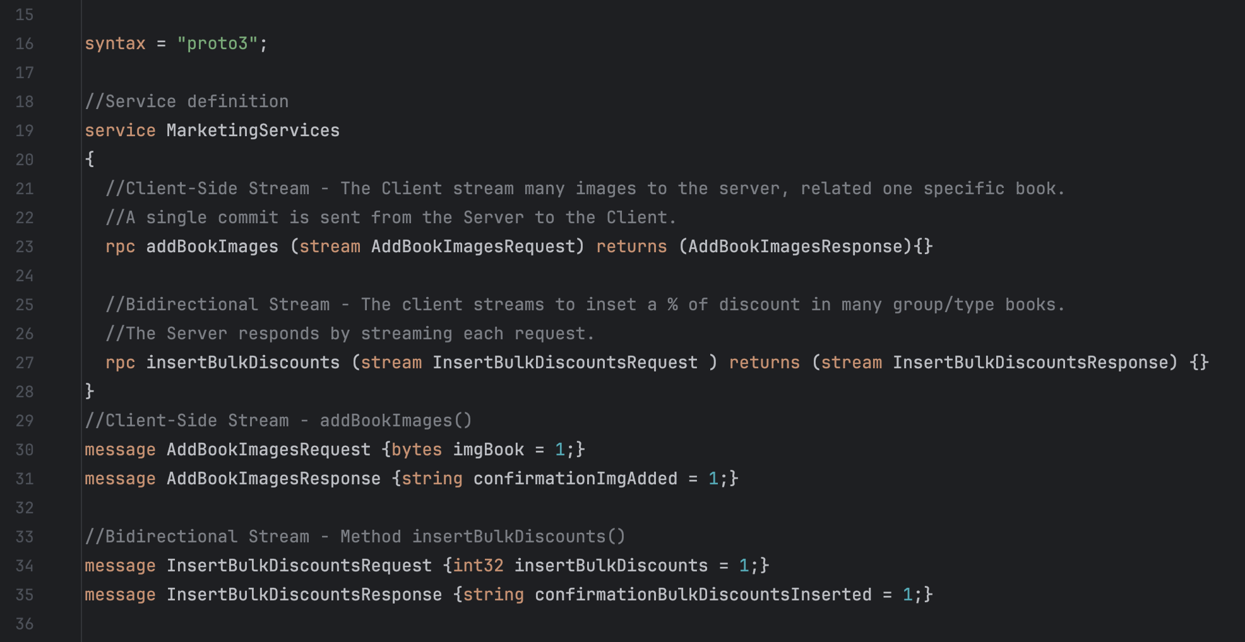

The Server Side Stream is the last method to be shown.

Through this service, the client sends a request to the server and gets a stream to read a sequence of messages back. The stream is read by the client until all messages have been read. The image bellow shows the service definition. Note that keyword “stream” is placed after returns.

This service implements the process where the user by sending only one request, gets from the server all books available.

The request and response are both executed using a string type.

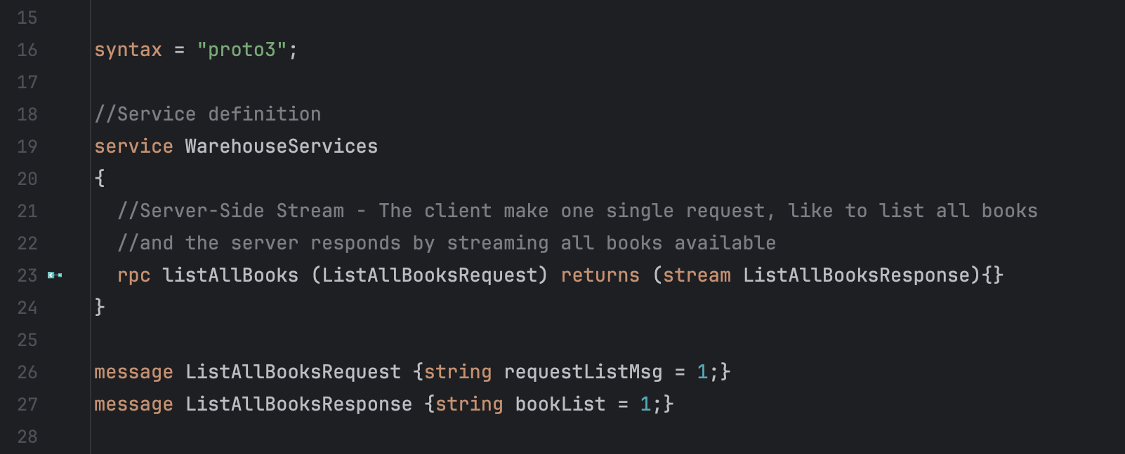

~~To apply the concepts presented in the classroom, using the idea of a smart home as a basis, I chose to approach the four gRPC services. Also, in an attempt to improve and reinforce my concepts in gRPC services, and assuming that practice leads to perfection, more than one version was built to explore the Java Swing and JavaFX topics.~~

~~The first two versions differ only in the graphical presentation, where one addresses command line concepts, and the second addresses the GUI graphical user interface through the Java Swing features.~~

**~~Please consider the third version as the main one to be evaluated. It includes GUI addressing JavaFX.~~**

**4. By using the MQTT protocol implement in Java the Publisher - Subscriber parts of the following application:**

**Your application simulates a smart office environment, where sensors emit different structural and air properties about the site.**

**Publisher One:** publishes messages every second about the room, like the floor/room/temperature (e.g 17 C) and the floor/room/humidity (e.g. 25%).

**Publisher Two:** publishes messages about the floor every half second,like the floor/light/ID (e.g ON) and the floor/window/location (e.g. OPEN/CLOSE).

1. **Implement these 2 publishers and demonstrate the sending of messages on these topics and subtopics.**

The publishers' implementation can be seen in the images below.

To enhance the efficiency of the organization, I divided each publisher into classes with a distinct focus.

Publish One, Humidity (%)

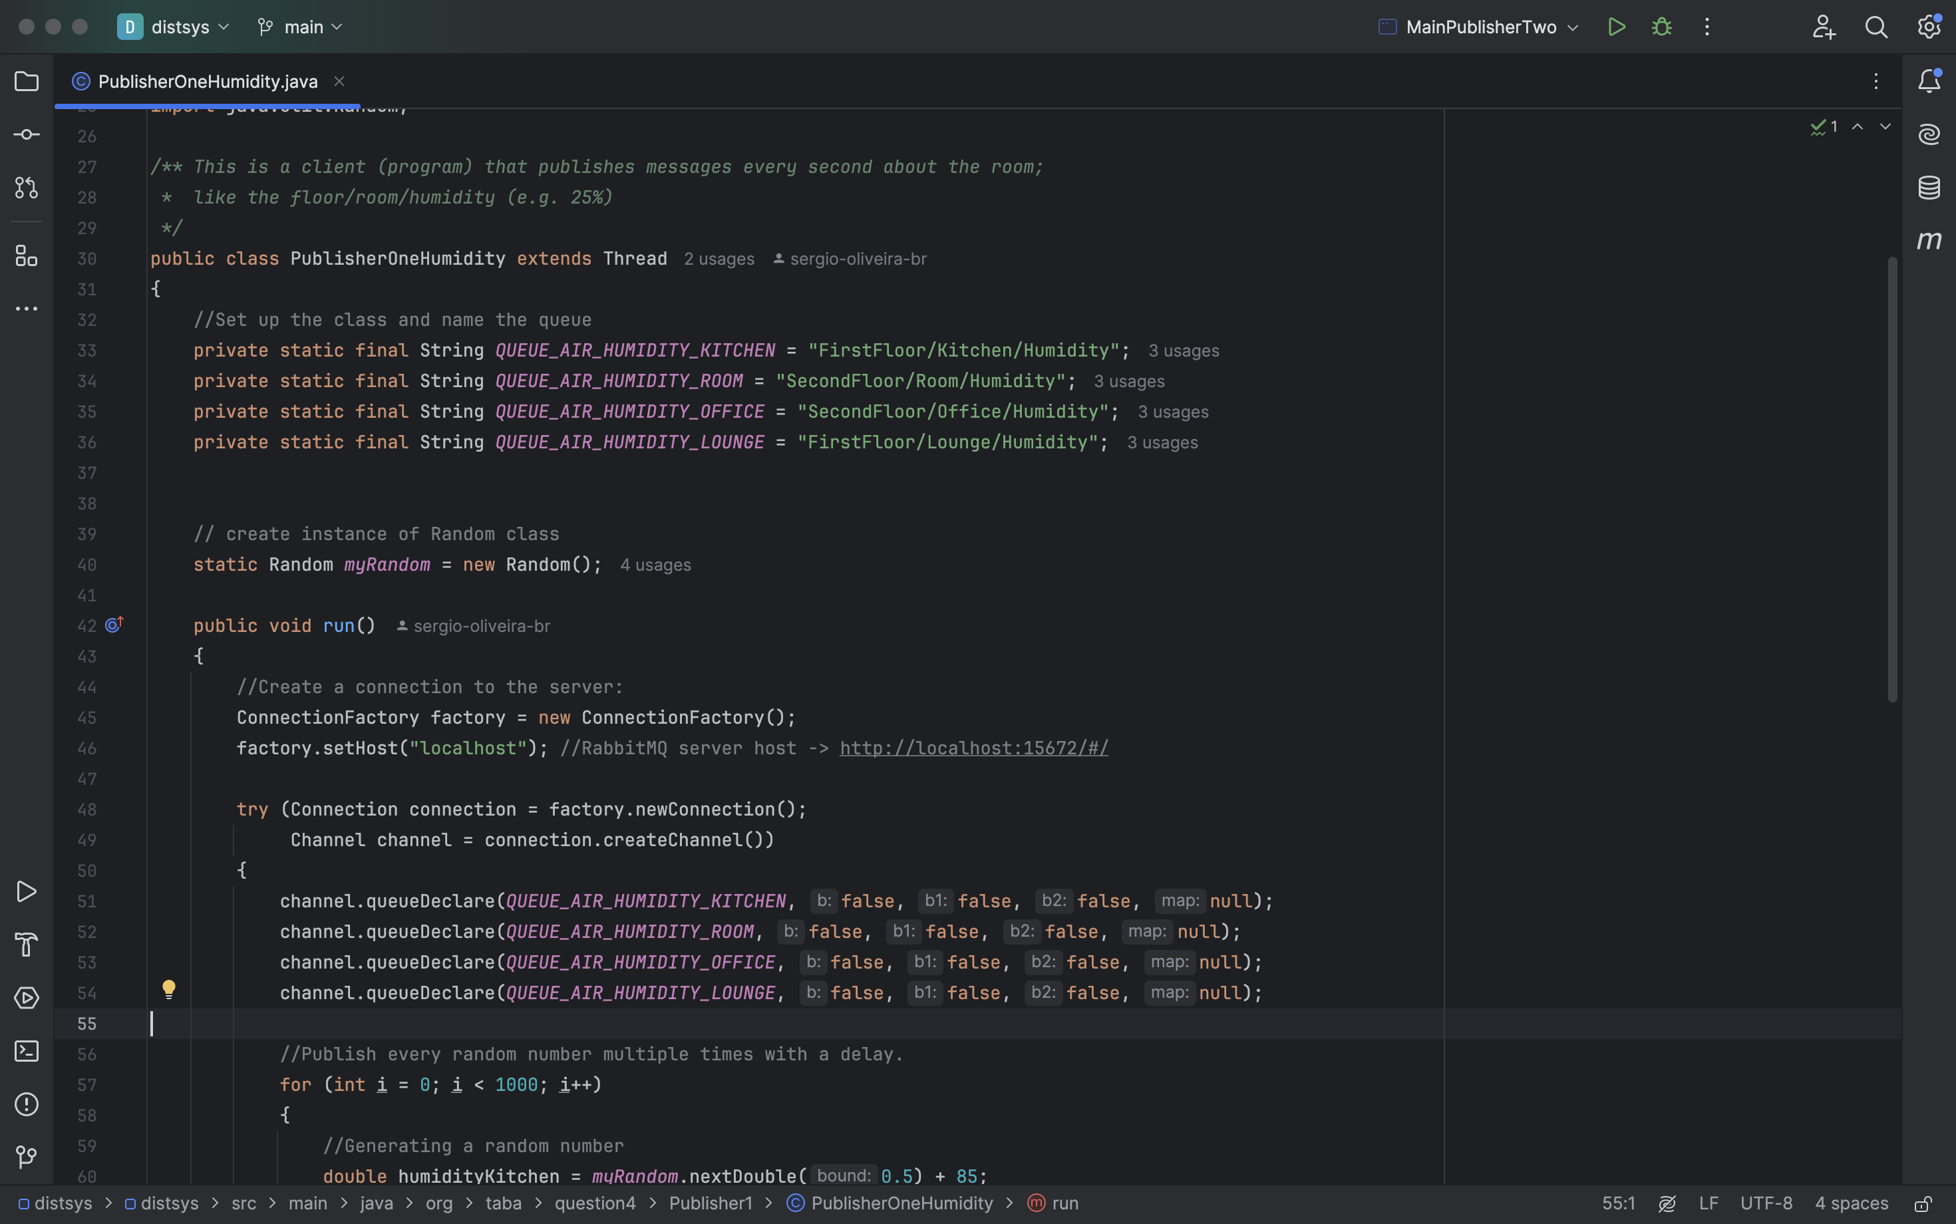

Publisher One – Temperature (ºC)

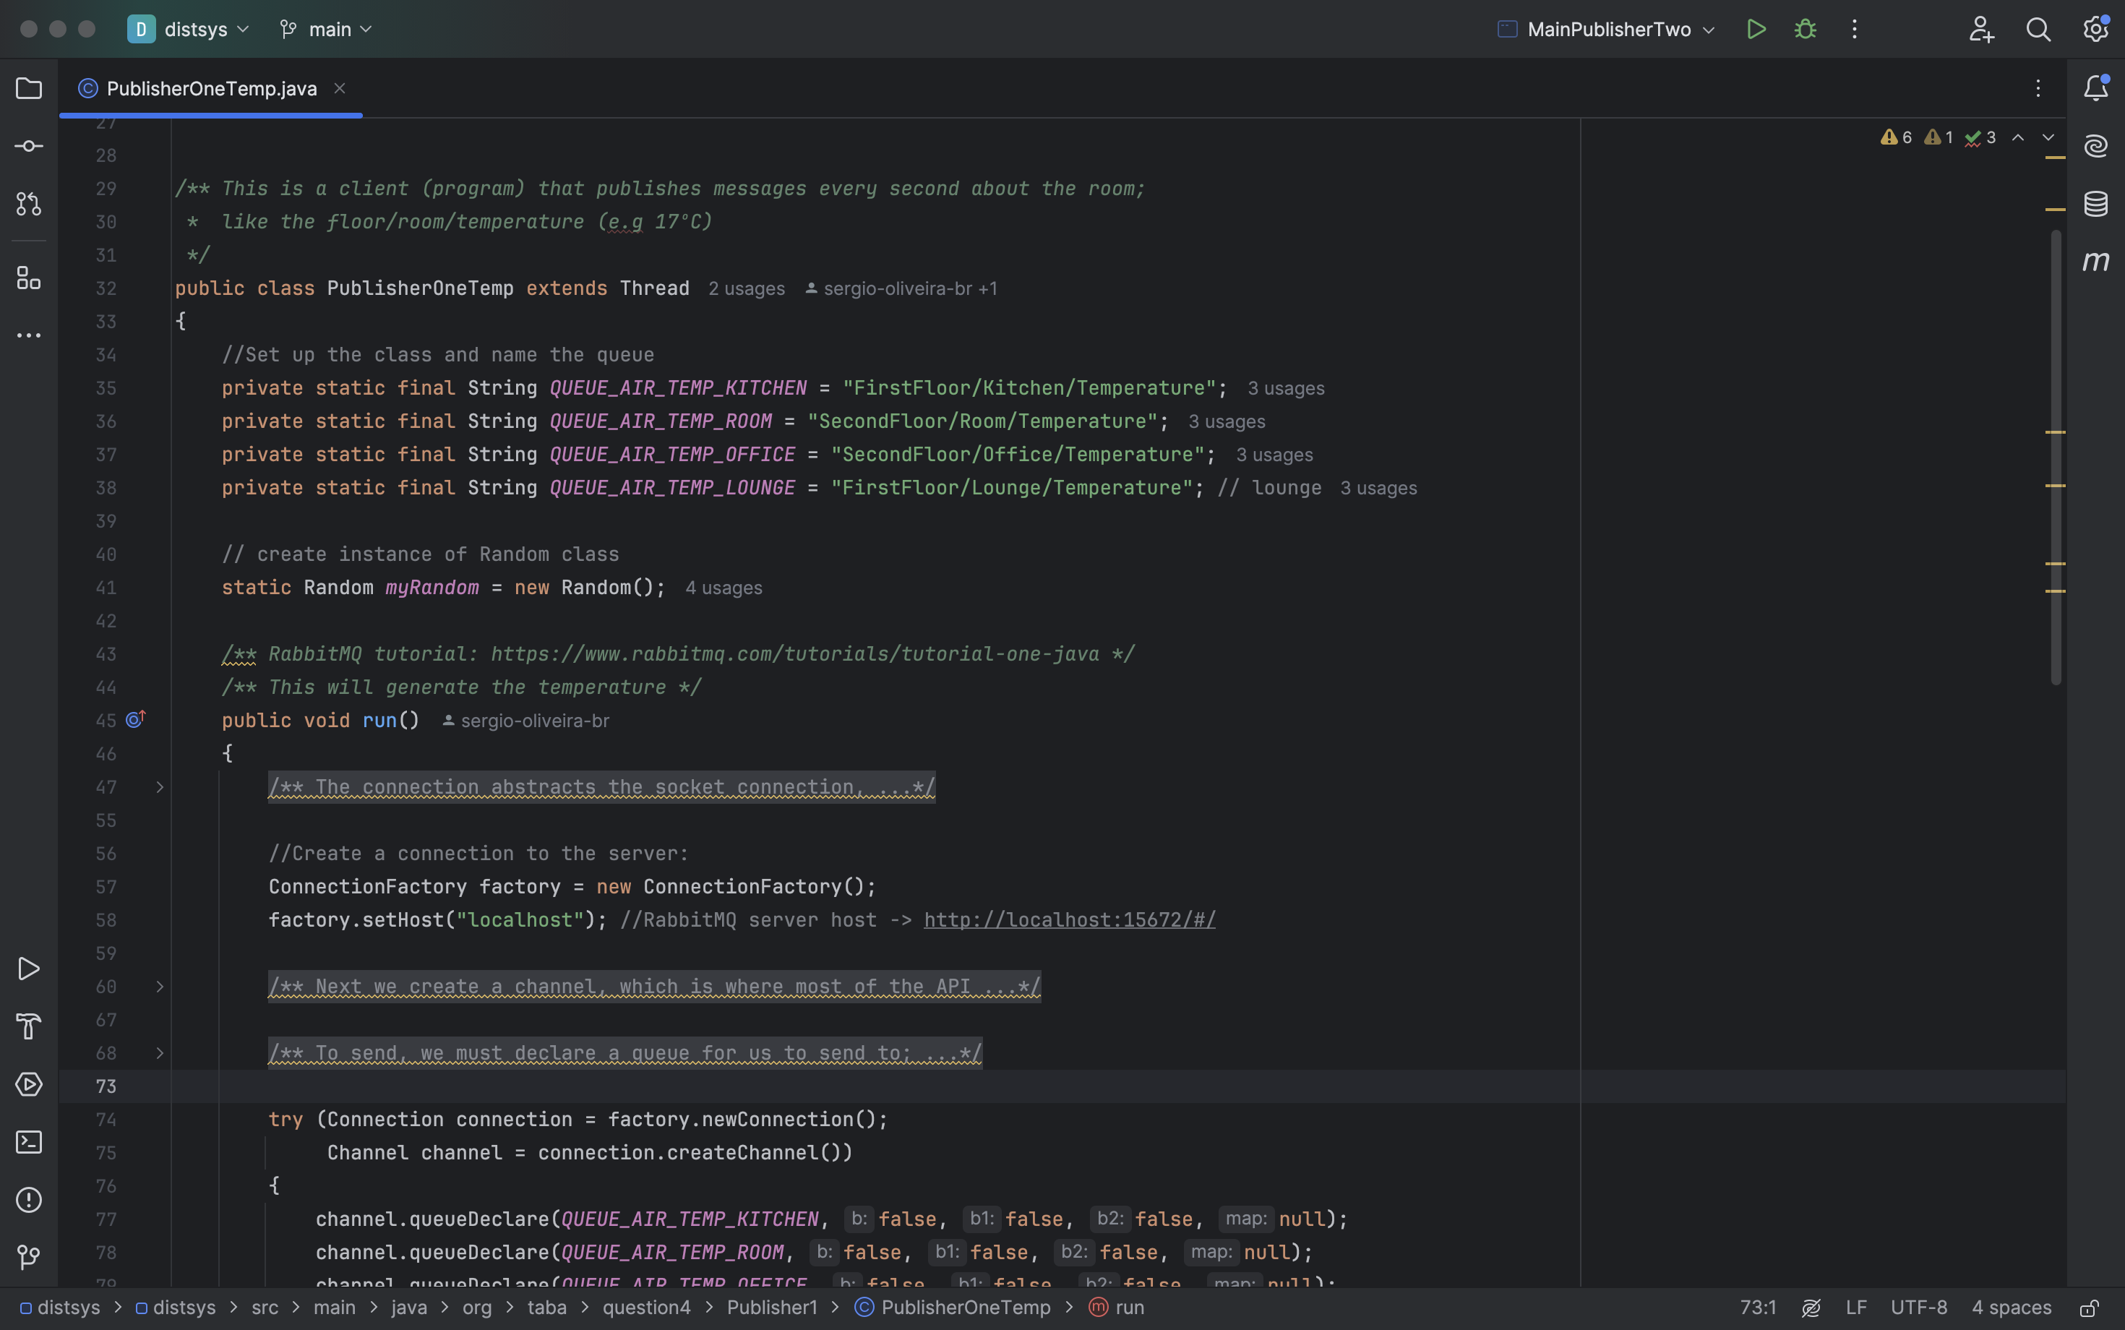

Main Method Publisher One

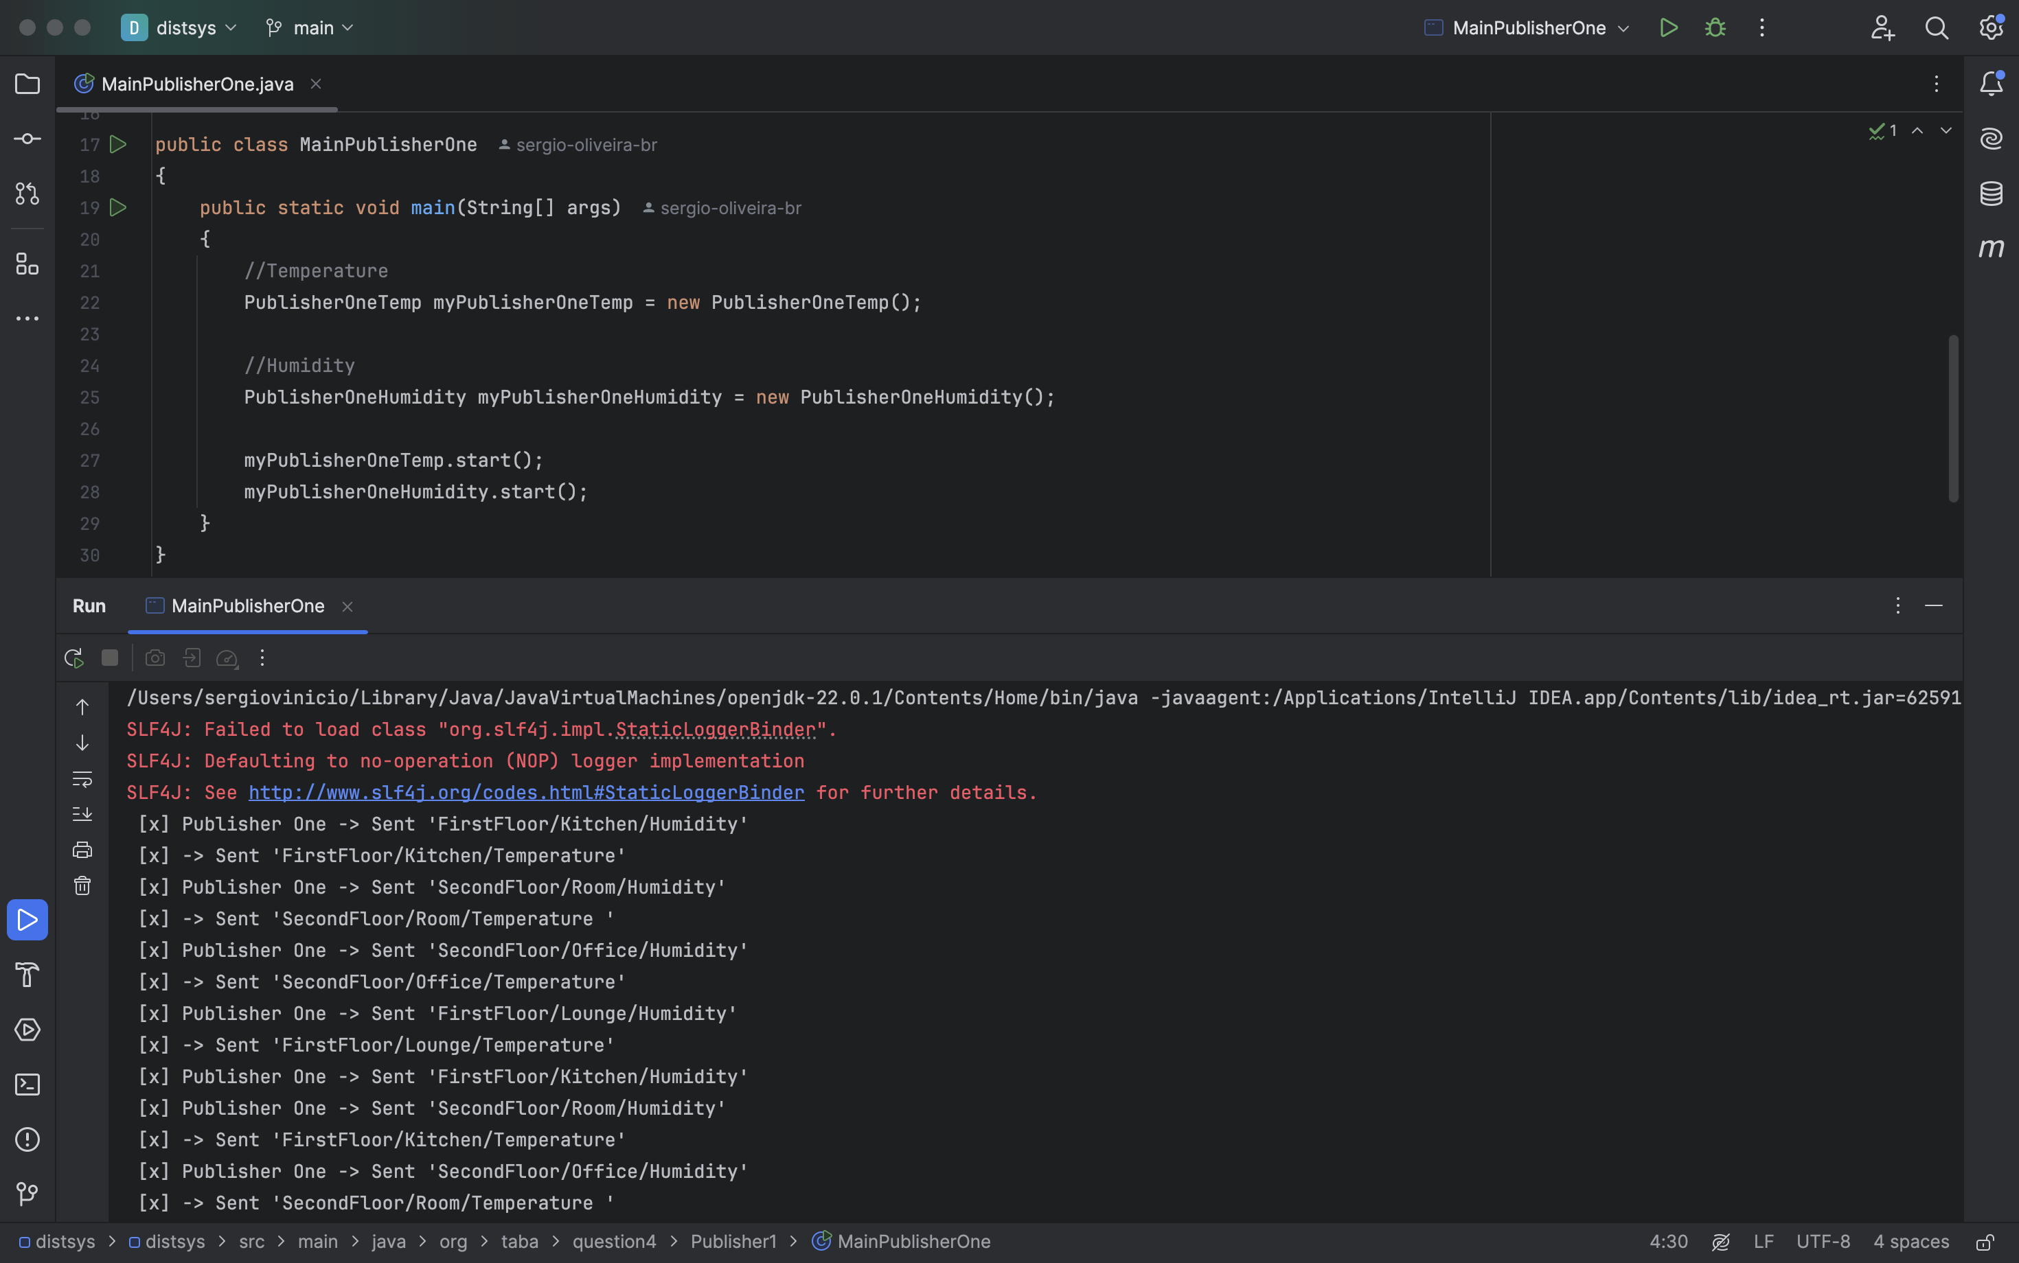

Publisher Two – Lights

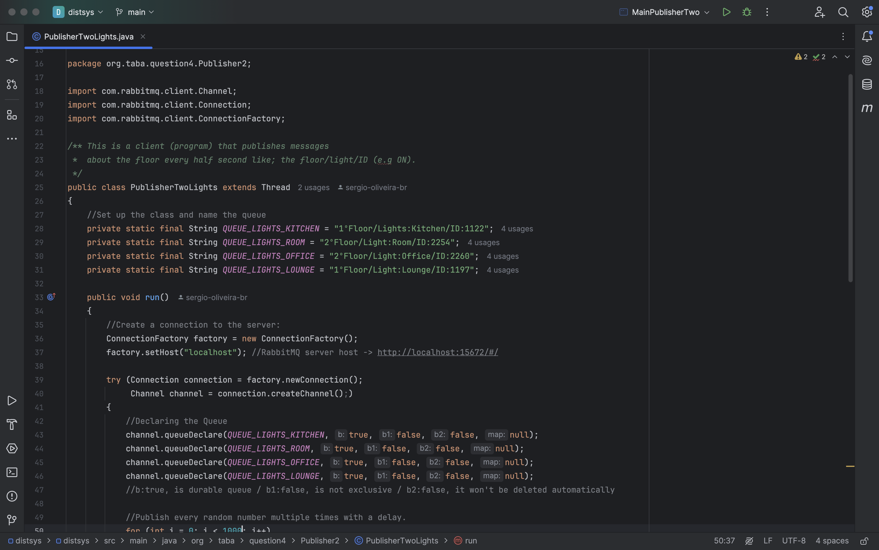

Publisher Two – Window

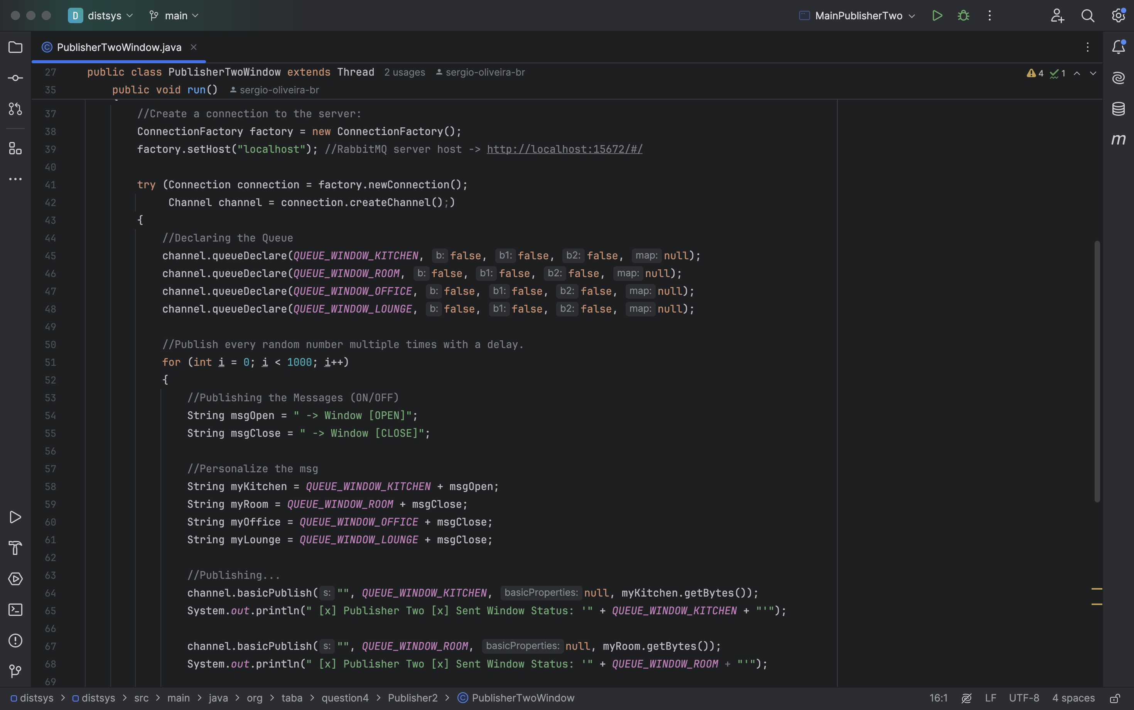

Main Method Publisher Two

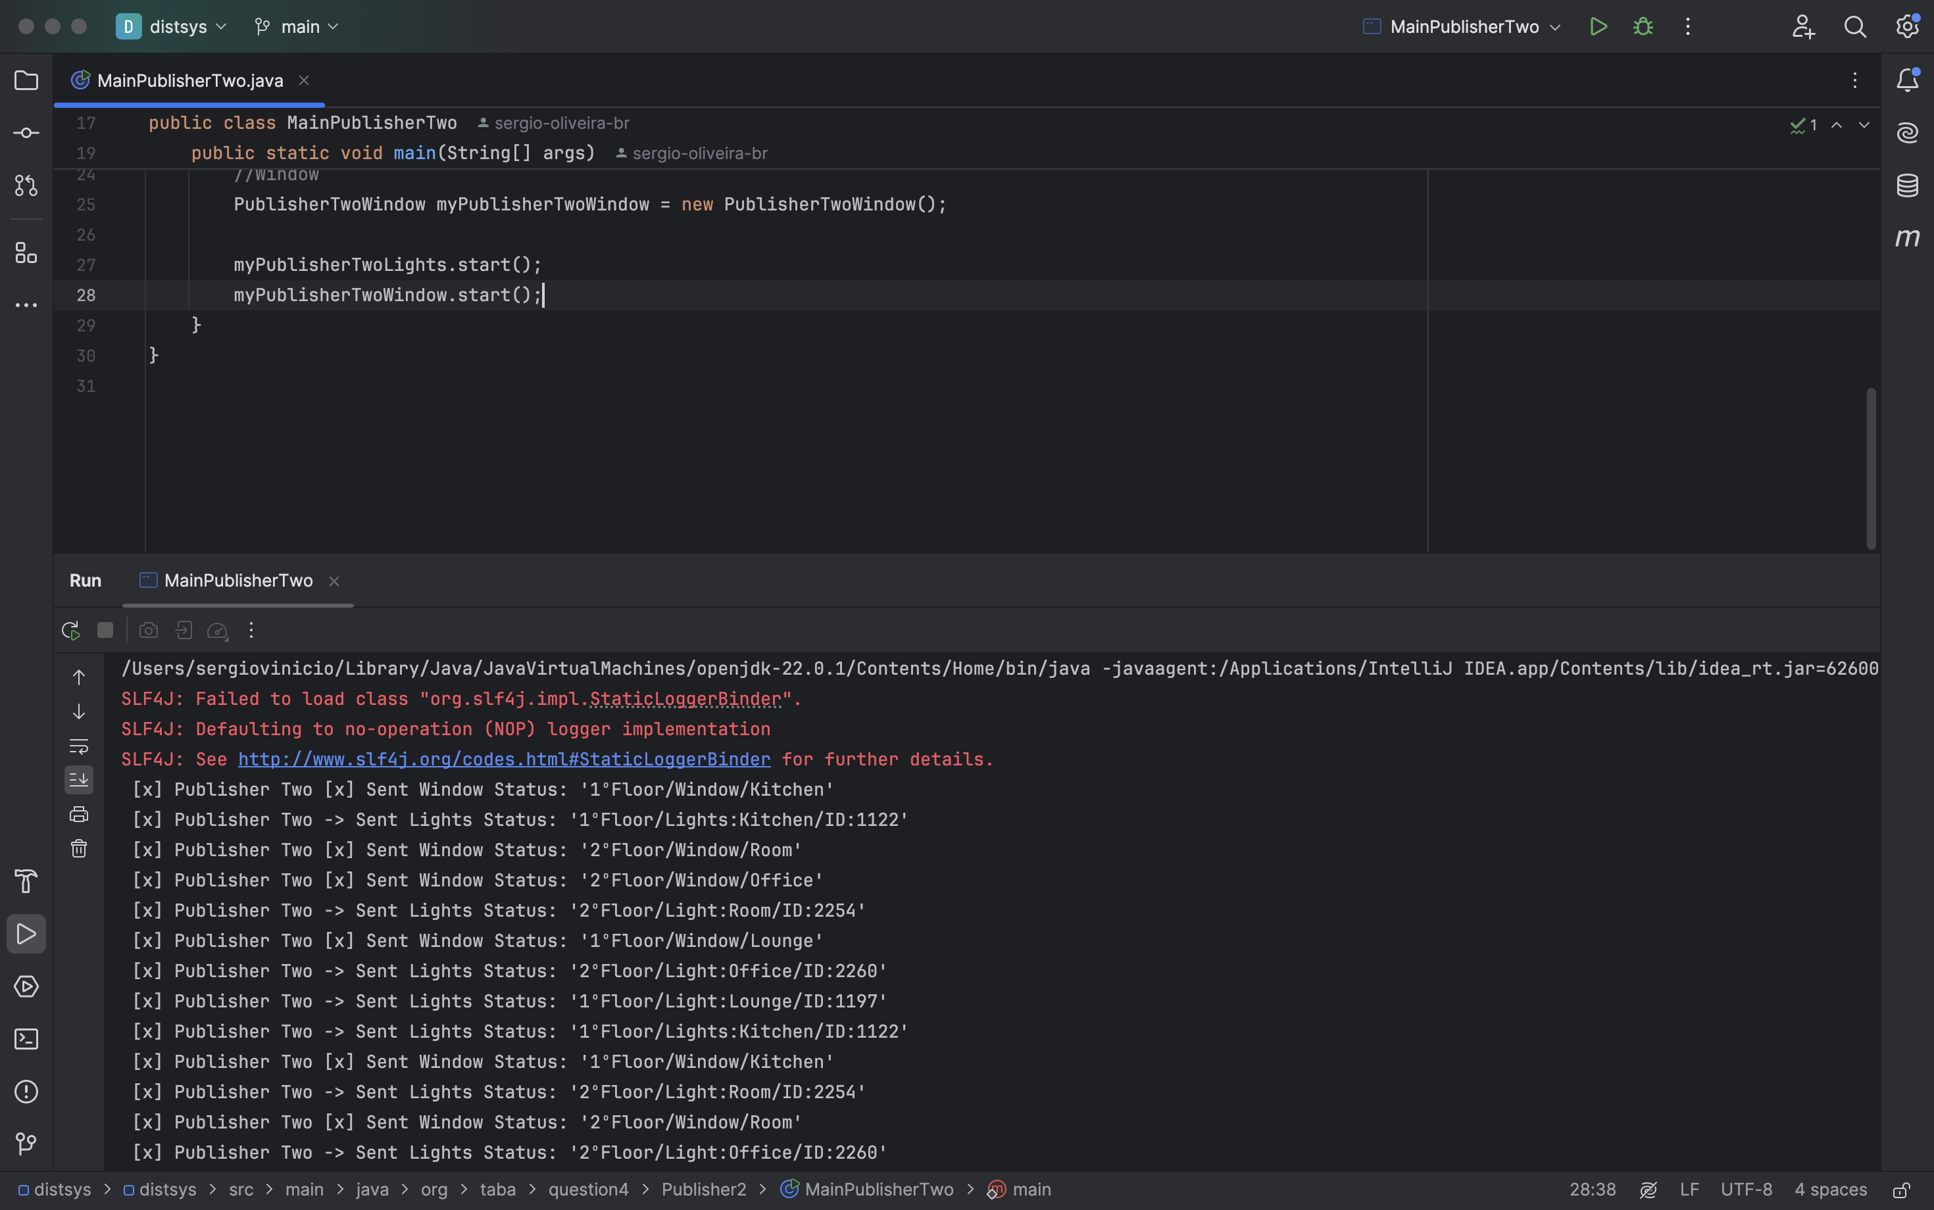

Run different subscribers to listen to messages:

1. **Strictly messages related to a floor/room/temperature.**

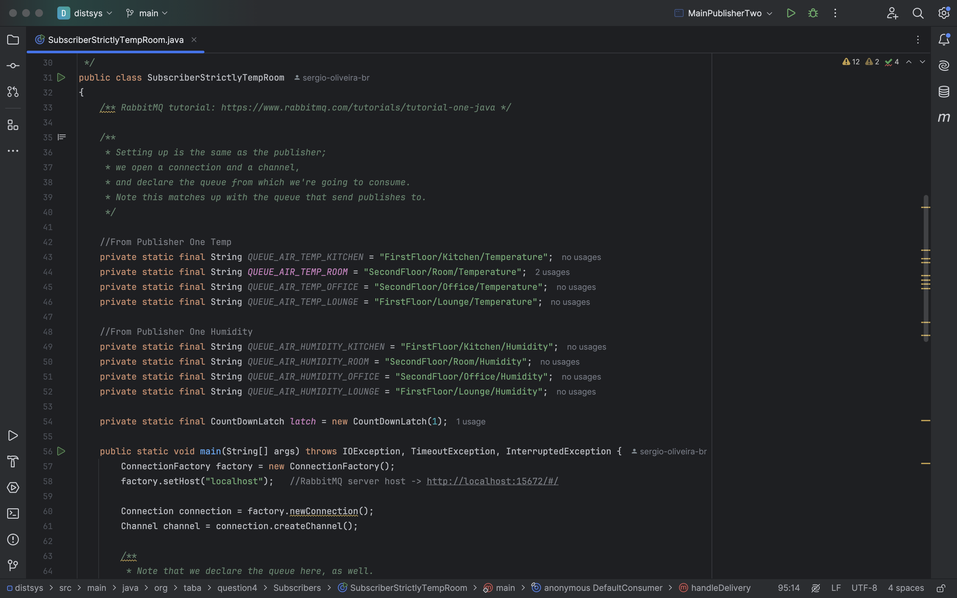

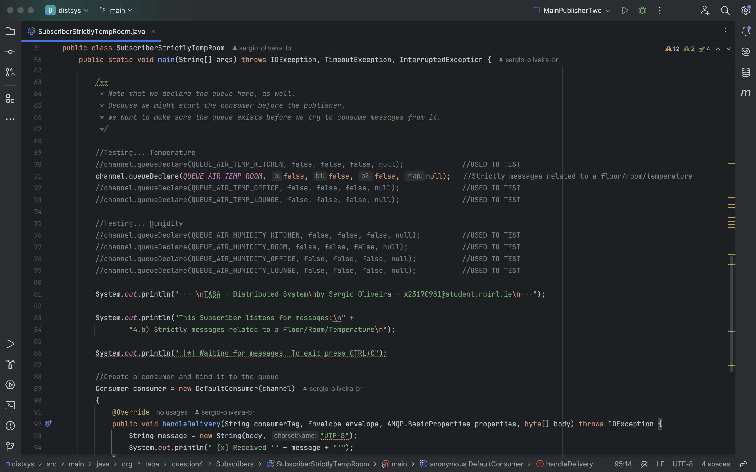

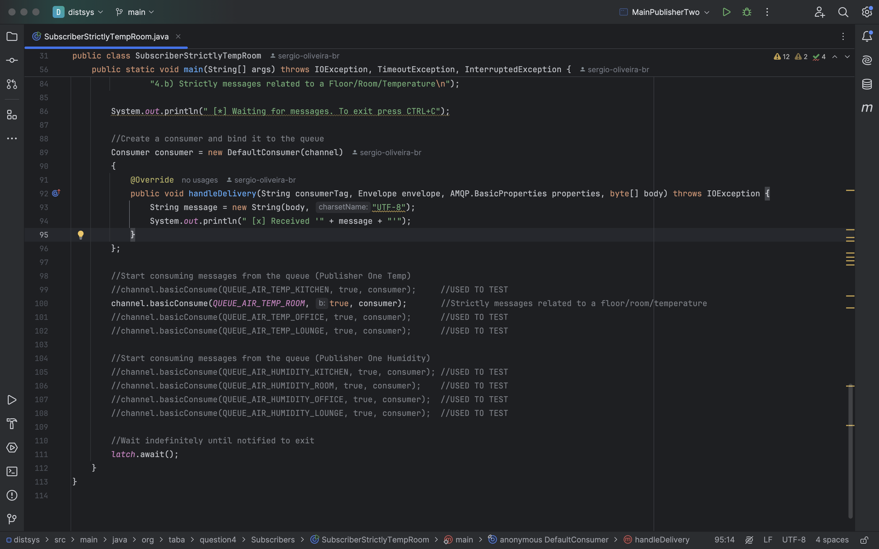

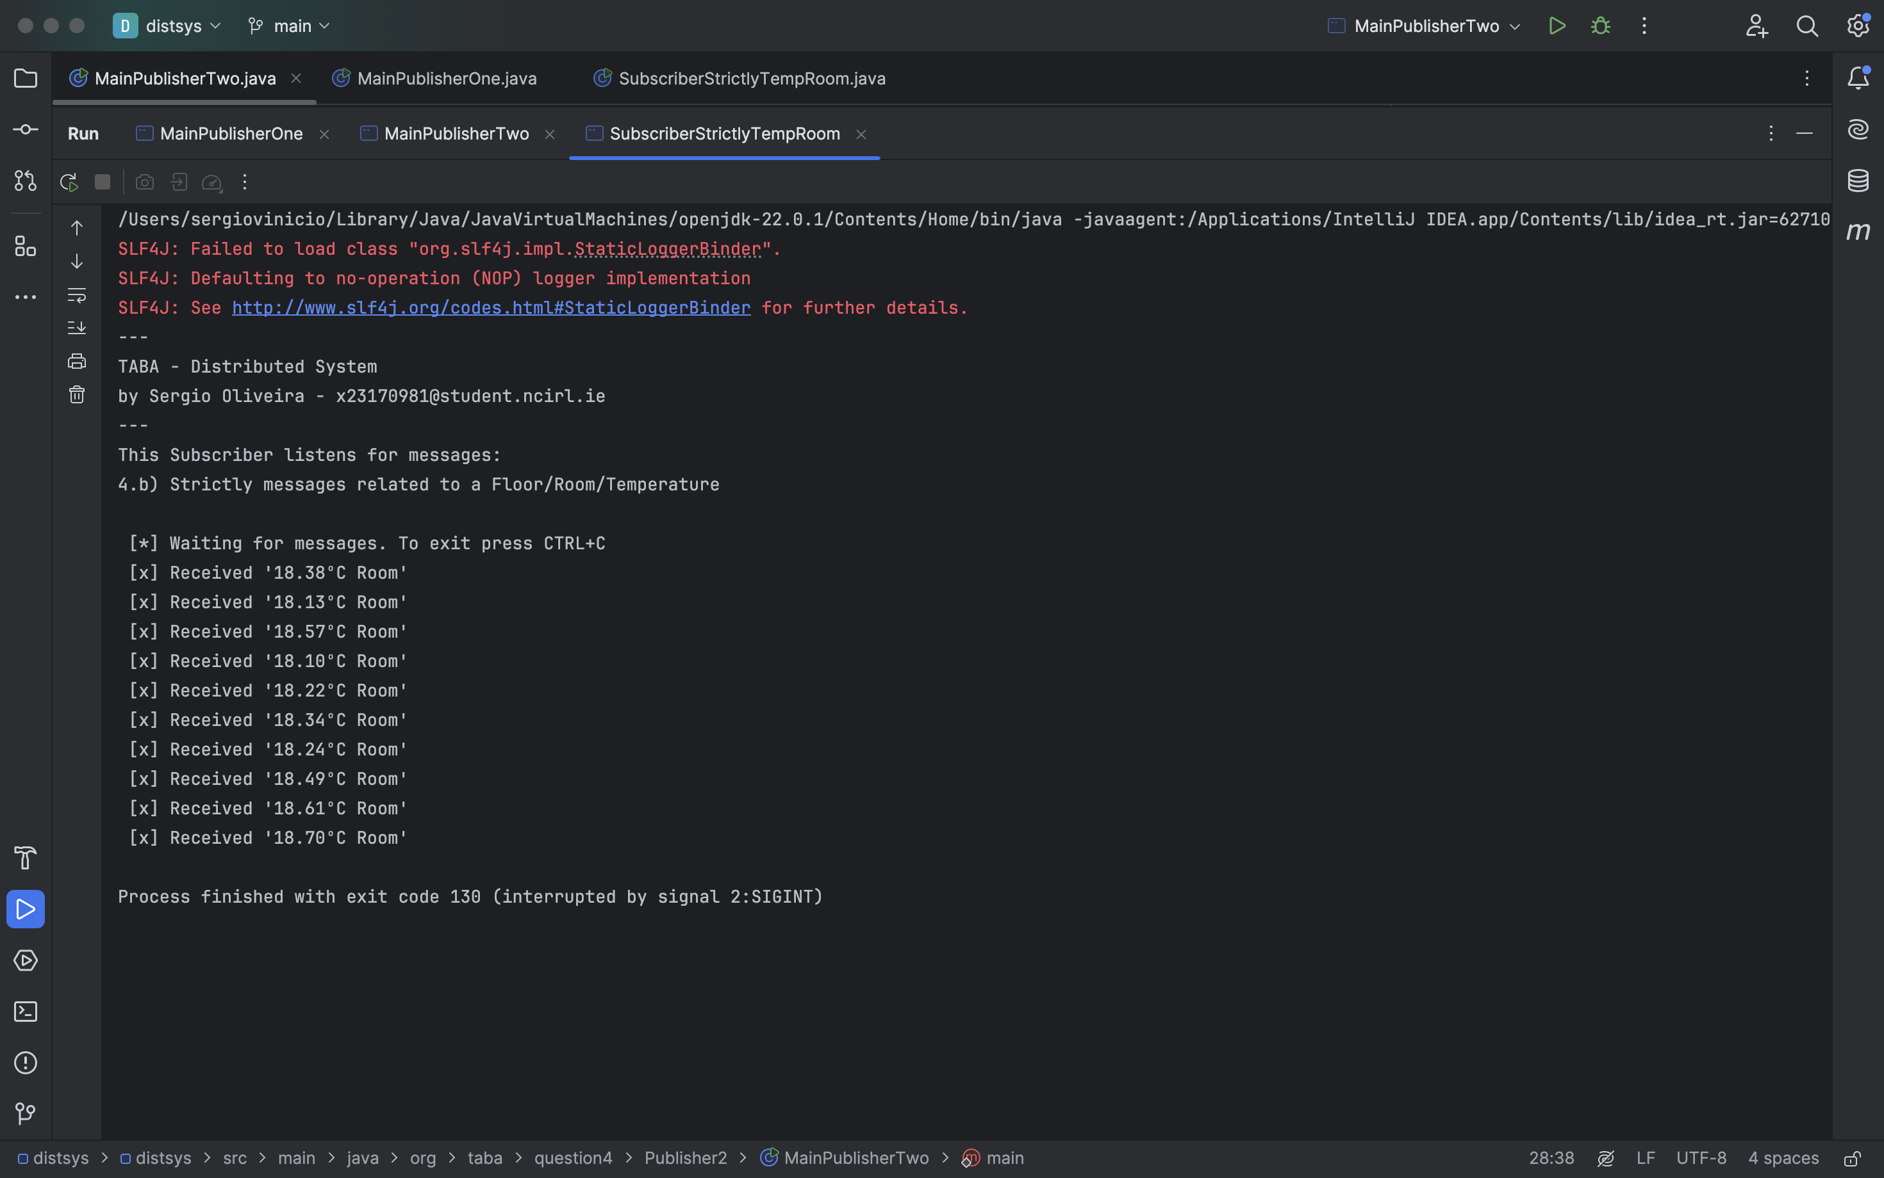

1. **Any messages that are related to room (including its subtopics)**

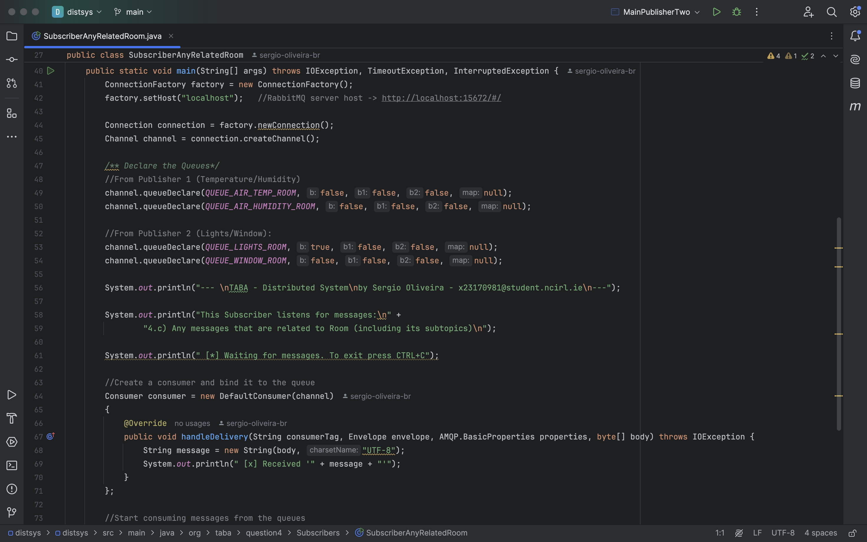

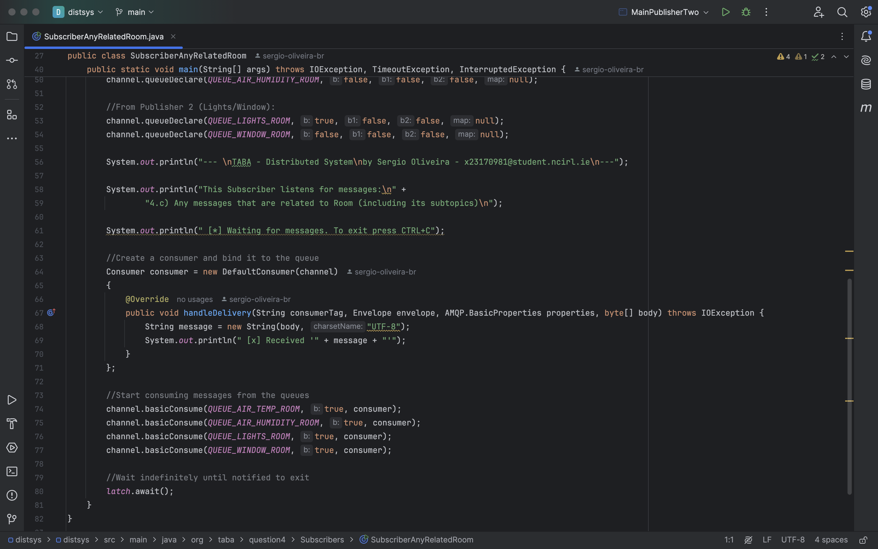

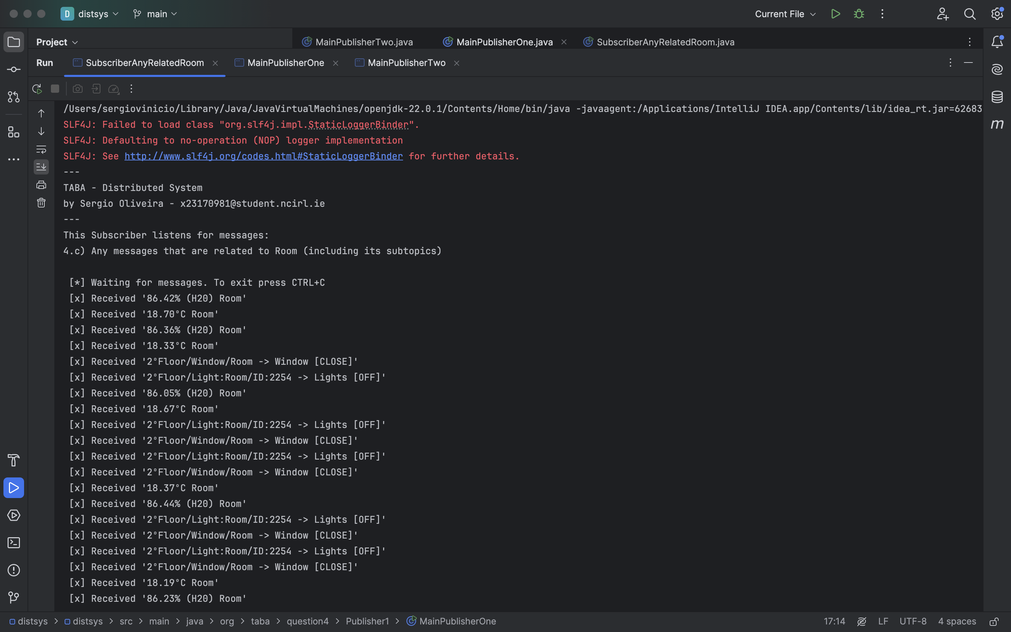

1. **Messages that are related to the floor for both light and window.**

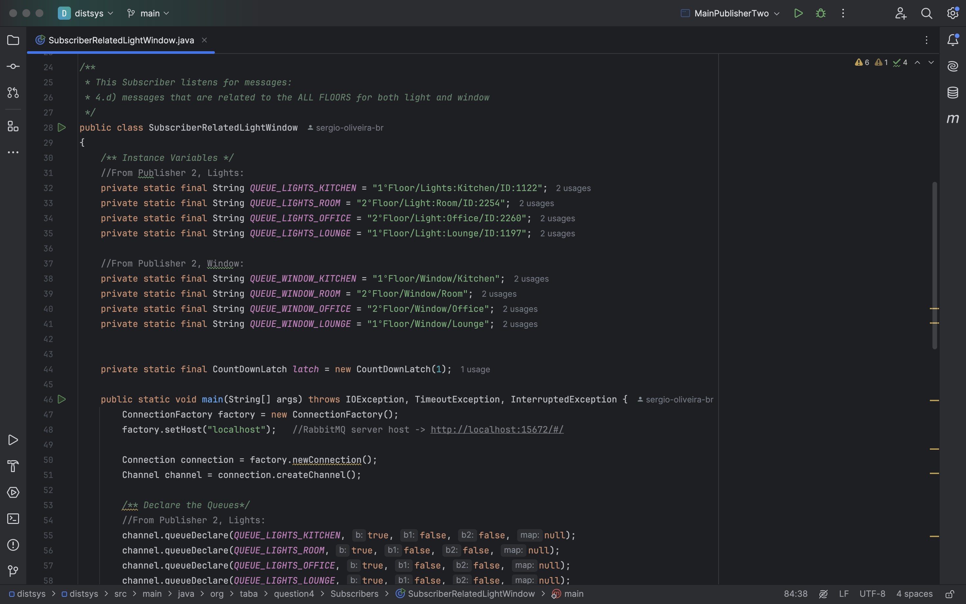

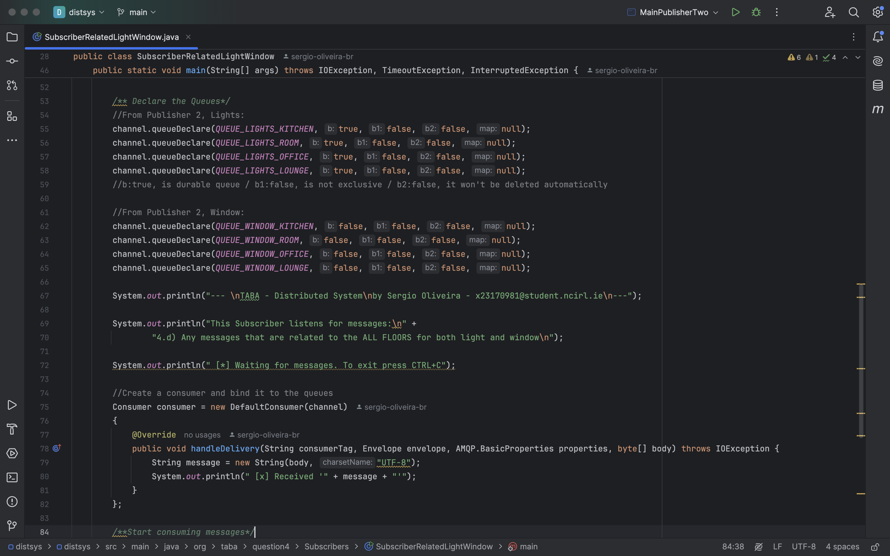

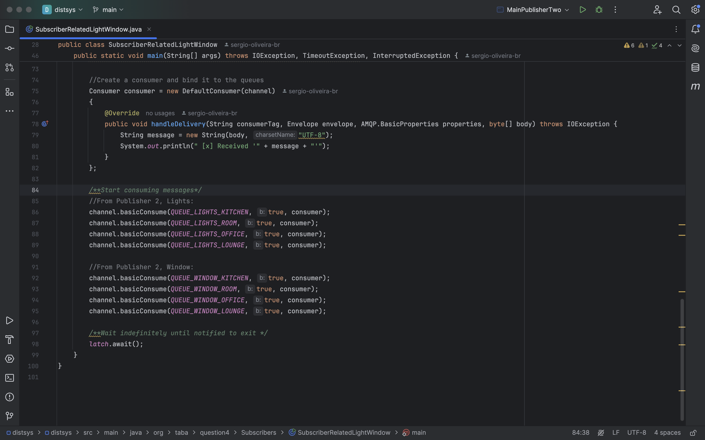

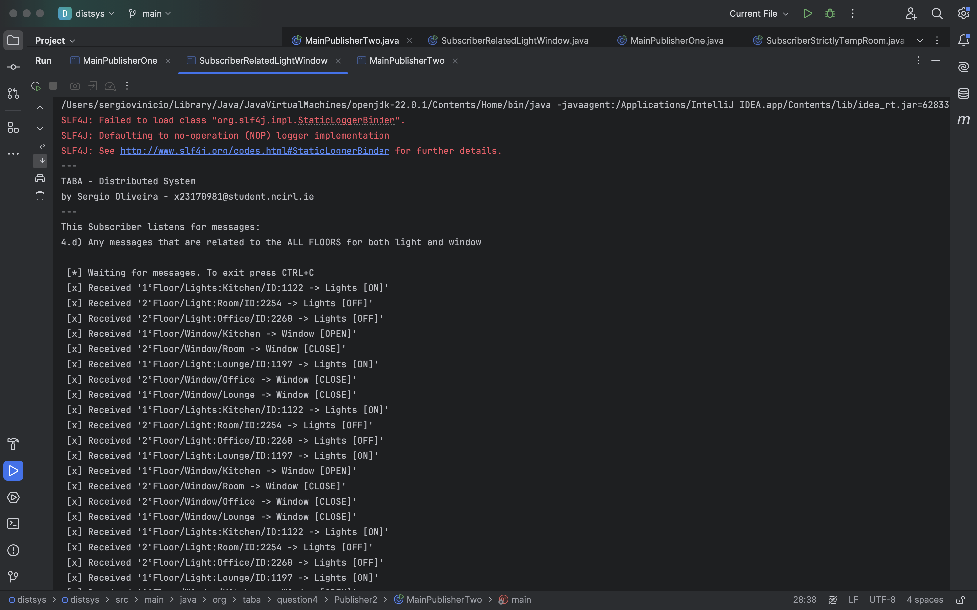

1. **Finally, show and explain how you can facilitate disconnected clients.**

**5.a) Conceptually demonstrate a simple client-server application/scenario, including and details about the relations and interactions among the following components.**

In essence, a connection is made up of three primary services, which are: Connection, Client Sends, Client Receives.

For instance, I will make use of Sockets technology.

A socket is an object that represents a network connection between two machines, establishing a *relationship* between two software, and enabling *communication* between them.

“Socket connection means the two machines have information about each other, including network location (IP address) and TCP port.”

Kathy Sierra, Bert Bates (2005) *Head First Java*. 2end edn. Sebastopol, CA: O’Reilly.”

By extending this concept, we can incorporate *middleware* into the relationship between the client and server, acting as an intermediate layer that facilitates communication between the two.

The objective of Middleware is to facilitate the development of distributed systems, and it can perform roles such as, validation and security functions, among others.

Due to the presence of this middleware, the client connects to it, which then connects to the server. In this scenario, the middleware receives the information that the user intends to transmit and manipulate it as needed before transmitting it to the server.

In addition, Middleware also plays a key role in *registry* connected clients by recording client information, and details of that sessions.

As a result, Middleware is essential not only for client-server communication but also for managing client connections.

This relationship can be demonstrated through the image below.

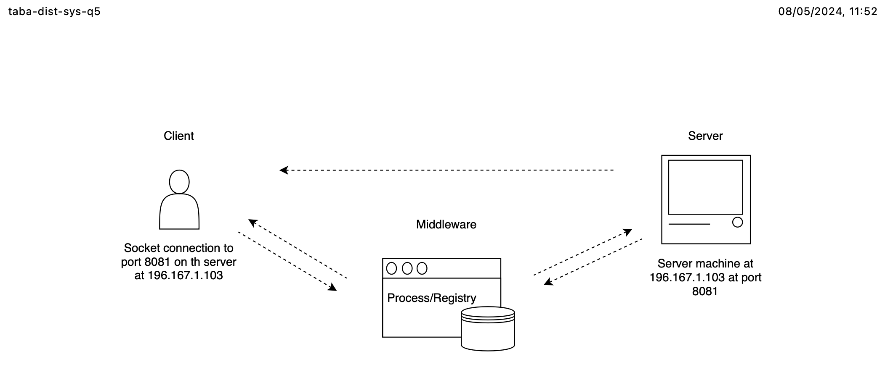

In a chat program, this concept can be used to create a hypothetical scenario. The image below demonstrates in 4 steps the process of interaction between clients and servers using the Socket environment. In other words, it summarizes what was discussed earlier.

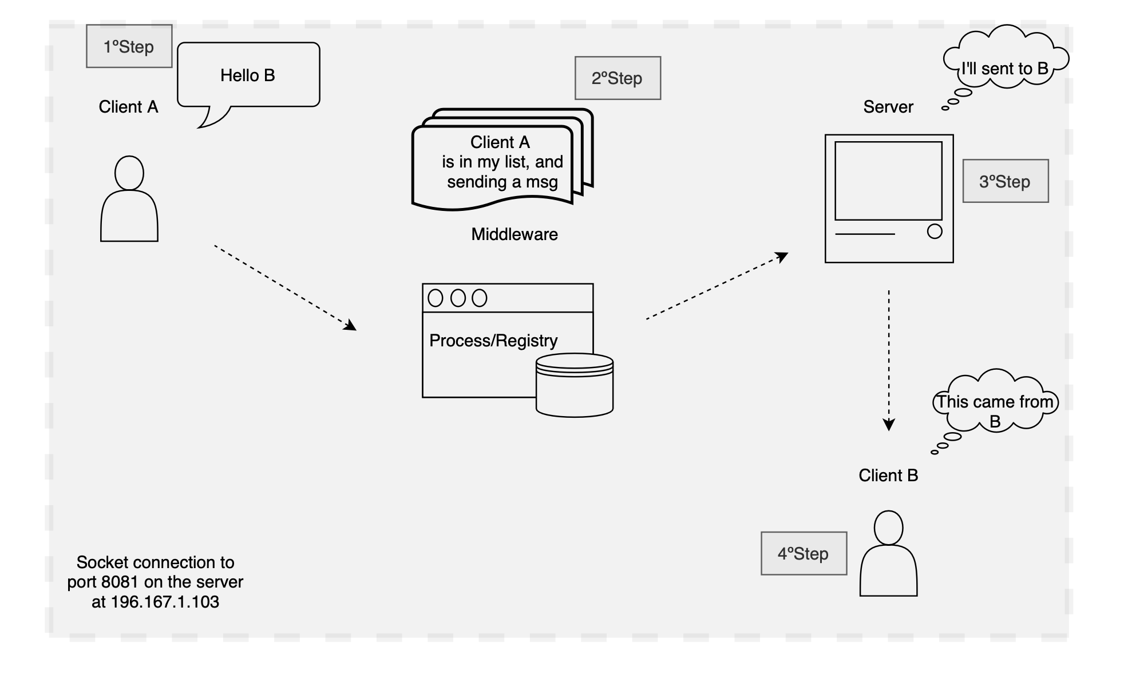

**5.b) Investigate and report how cloud-based systems balance the trade-offs of the PACELC theorem, and what approaches they take to guarantee Consistency, Availability and Partition Tolerance.**